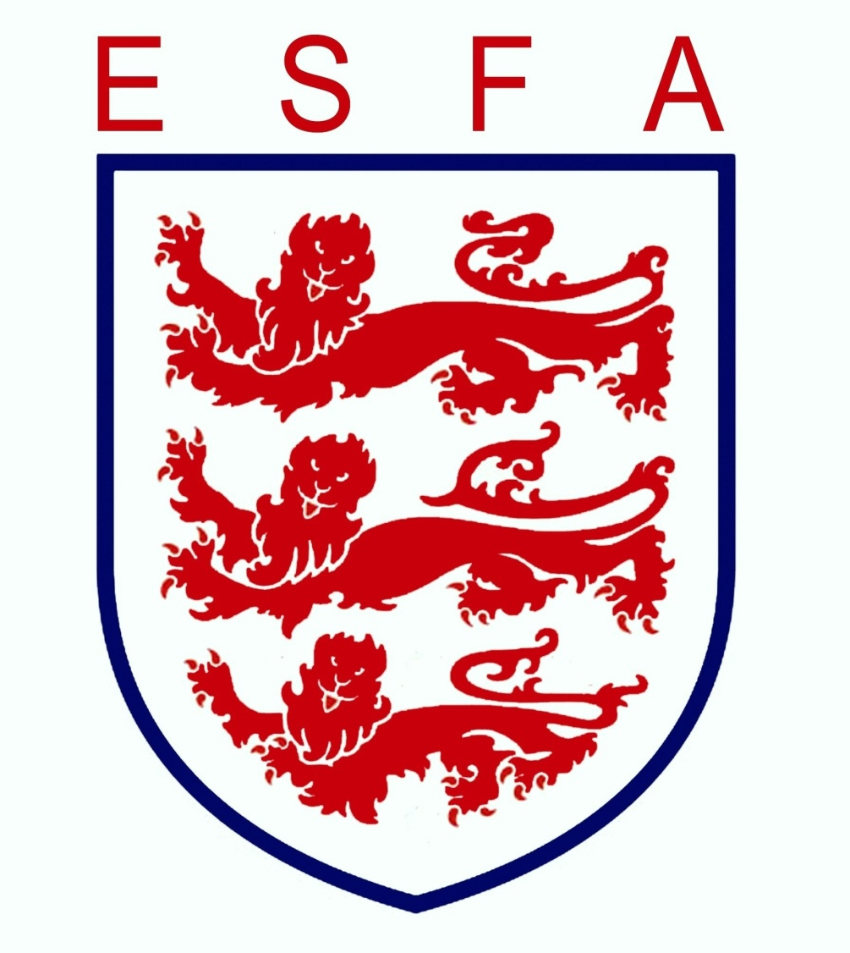

CERTIFICATE OF MERIT
SEASON 2017-18

NAME: ____________________________________

COMPETITION: ____________________________________

Awarded by the English Schools’ Football Association
for participation in Schools’ Football
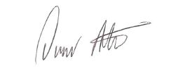

Owen Aiston
Chairman ESFA 2017/18

